From: Highland Good Food <catriona@highlandgoodfood.scot>
To: Highland Good Food Partnership <hello@highlandgoodfood.scot>
Sent: 20/10/2022 16:57:48
Subject: Support for crofters and small farmers

Support crofters and small farmers!
We are gathering supportive messages for the Day of Action planned outside the Scottish Parliament this Tuesday (25th) where we are calling on the Scottish Government to recognise and support the work of small farms and crofts via the Agriculture Bill. We want messages of support to be seen/heard at the event, particularly from those who cannot attend.
What are we asking for?
Send us a picture of yourself to hello@highlandgoodfood.scot; a food/farming/crofting related background would be amazing but not essential. Send us a quote/message asking for agricultural bill support for small farmers and crofters. Let us know if you'd like to use one of these quotes below (personalised messages and quotes very welcome/preferred):
- For the Agriculture bill to stand up for nature and good healthy food it must support crofters and small farmers. We need #GoodFoodGoodFarming
- We need good food and good farming. We need an Agriculture Bill that supports crofters and small farmers.
- I am supporting small farmers and crofters
We will create something like this example, with your message of support, name, occupation and approximate location. We will print out and present the images on the day -so the more we can gather, the more impactful this will be!

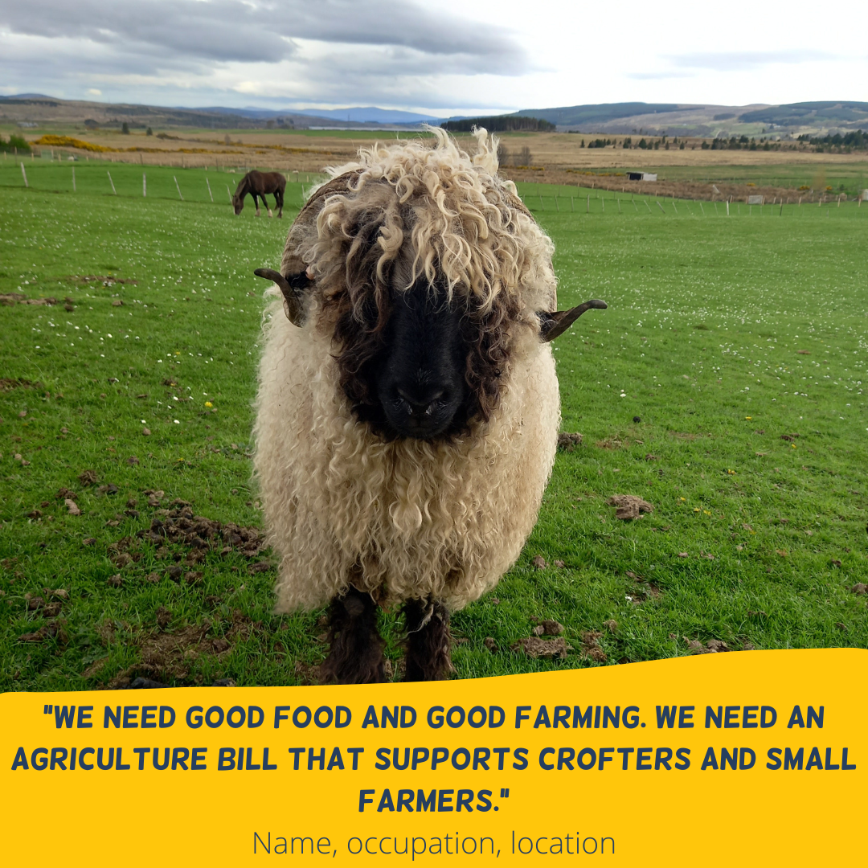

IMPORTANT INFO: We will use this image, including a message of support on our social media and a printed version on the day at the Scottish Parliament. Please be aware that by sending us a photo you agree to this. Thank you.

